**aCONTROL FLOW STATEMENTS:**

condition

**1.if :**

**TRUE**

Code/statements after if block

Code/statements inside if block

If(Boolean function){

Statement 1;

Statement2;

**FALSE**

….

}

**2.If-else :**

**FALSE**

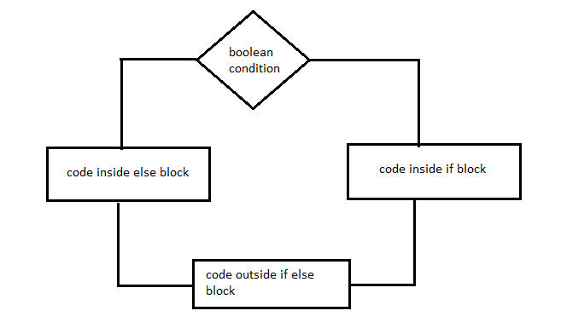

**TRUE**

>When we have more than one boolean conditions

**If-else-if**

>when we have multiple Boolean condition (n conditions)

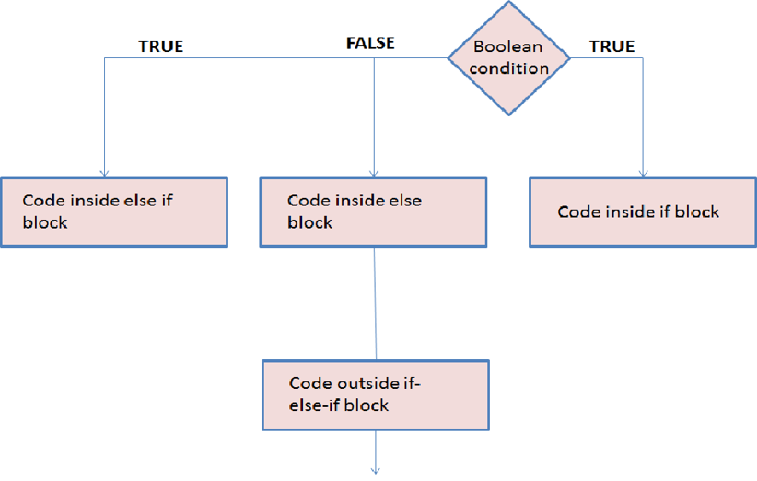

**SWITCH:**

condition

Code inside switch block

Case 3

Case 2

Case1

After each case, break statement is not mandatory but if not given then all the cases following accepted case will be executed. So, it’s good practice to use break

Default statement can be written anywhere inside switch case but if written in middle then break statement has to be included in and after the break.